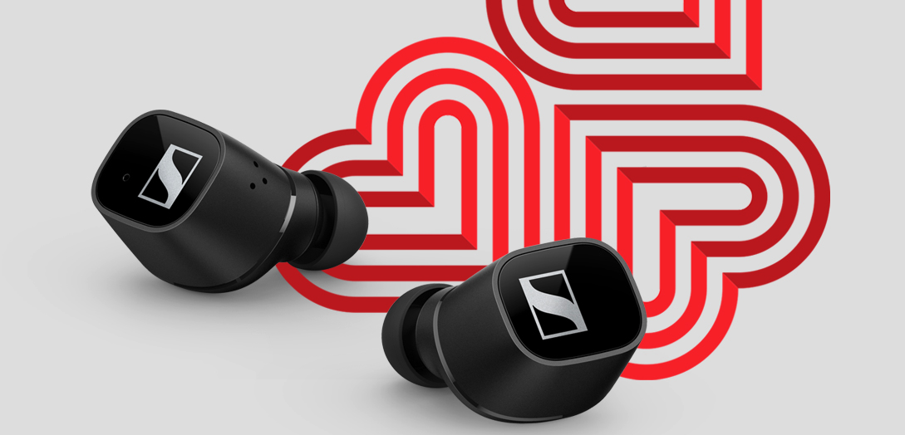

Make every song a love song
Celebrate Valentine’s Day with Sennheiser

SYDNEY, Australia – February, 2021 – All you need is love… but a little music never hurts. Feelings can be hard to put into words so why not express yourself through song this Valentine’s Day with a pair of headphones and a list of songs that remind you of the person who matters most to you. With styles to match every budget, every whim and every desire, Sennheiser will help make the romance last longer with a gift that keeps on giving long after the holiday passes.

One for you, one for them  CX 400BT TRUE WIRELESS  - Astonishing sound thanks to Sennheiser’s 7mm dynamic drivers  - Personalised listening experience with built-in equaliser so they can curate a sound that is perfect for them  - Customisable touch controls  - 7-hour battery life (+13 hours via the case)  - Available in black or white  - RRP $299.95 | 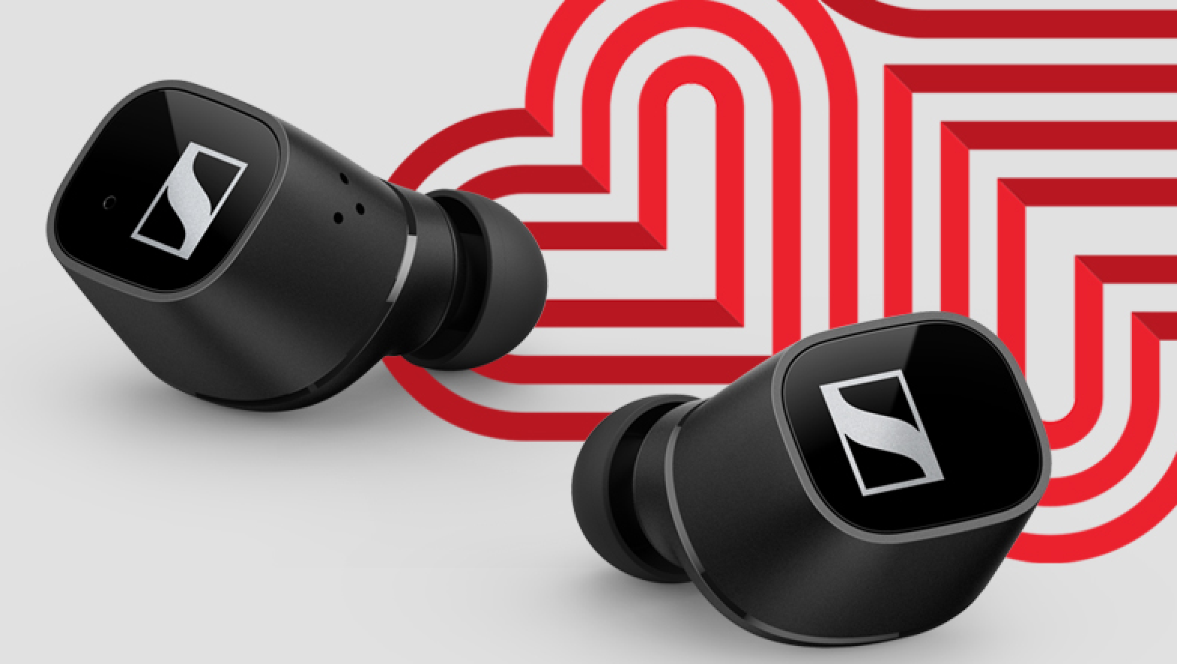

True wireless earbuds they’ll adore  MOMENTUM TRUE WIRELESS 2  - Exceptional sound featuring Sennheiser’s 7mm dynamic drivers  - Active noise cancellation  - Transparent Hearing feature that blends in ambient noise at a touch  - Customisable touch controls  - Smart Pause feature  - Exquisite craftmanship  - 7-hour battery life (+21 via the case)  - Available in black or white  - RRP $499.95 | 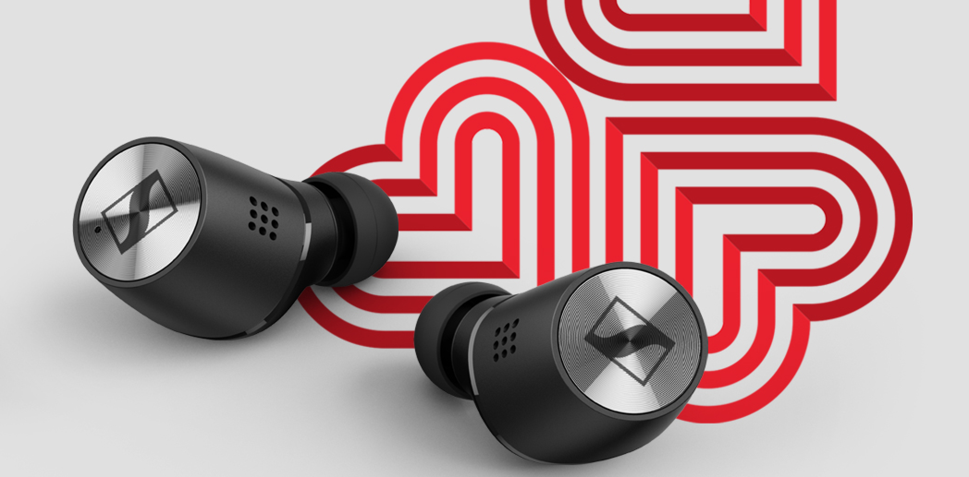

Wireless earbuds designed to delight on a budget
CX 150BT
- The perfect balance of audio quality, comfort, durability and affordability
- Advanced wireless Bluetooth 5.0 technology for seamless, reliable connectivity
- Superior audio with AAC and SBC codec support
- 10 hours of battery life and convenient USB-C charging
- Designed for comfort with four interchangeable ear tip sizes included for optimal fit and sound isolation
- Call and music management via three-button remote
- Effortless multi-connection pairing for two devices
- RRP $109.95

For your travel partner
PXC 550-II WIRELESS
- Wireless headphones created for a smart and sophisticated travel experience – perfect for romantic getaways
Undisturbed, superior sound in any environment with adaptive noise cancellation
- Intuitive operation via touch pad
- Convenient one-touch access to voice assistants
- Travels the world on a single charge: up to 20 hours of battery life with Bluetooth and ANC switched on, and up to 30 hours when using ANC and a wired connection
- RRP $549.95

For those that are always out and about
HD 350BT
- Great sound with deep dynamic bass
- Flawless transmission assured by the latest wireless technology, including Bluetooth 5.0 and high-quality wireless codecs
- An impressive 30-hour battery life and fast USB-C charging
- A compact folding design that fuses comfort and minimalist style
- Available in black or white
- RRP $199.95

For the perfectionist in your life  MKE 200  - Directional microphone for enhanced in-camera audio – the perfect gift to fuel your partner’s creativity  - Compact design with sleek and stylish finish  - Integrated wind protection and internal suspension mount to minimise handling noise  - Interchangeable 3.5mm (1/8") TRS and TRRS connectivity for use with DSLRs/DSLMs or mobile devices  - Standard cold shoe mount for universal use  - Battery-free operation  - RRP $199.00 | 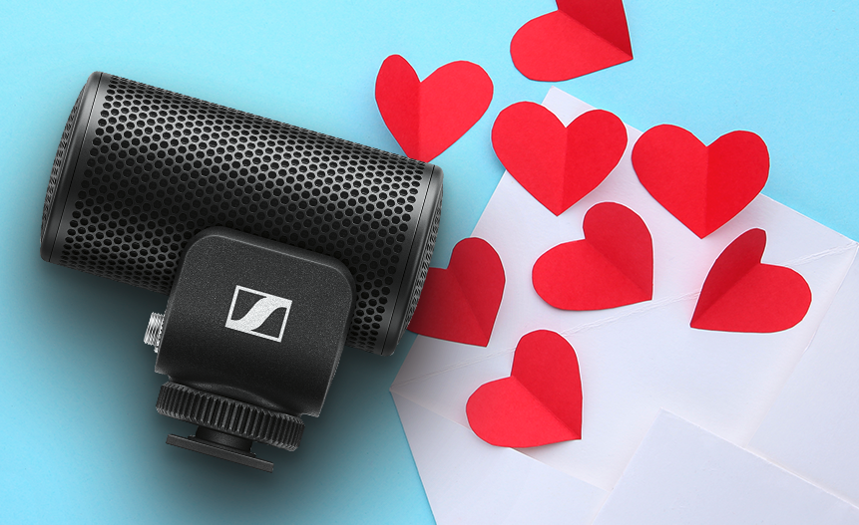
For current sales and offers, please visit: www.en-au.sennheiser/sales
About Sennheiser
Shaping the future of audio and creating unique sound experiences for customers – this aim unites Sennheiser employees and partners worldwide. Founded in 1945, Sennheiser is one of the world’s leading manufacturers of headphones, loudspeakers, microphones and wireless transmission systems. Since 2013, Sennheiser has been managed by Daniel Sennheiser and Dr. Andreas Sennheiser, the third generation of the family to run the company. In 2019, the Sennheiser Group generated turnover totalling €756.7 million. www.sennheiser.com

Press Contacts

Caitlin Todd
caitlin.todd@groundagency.com
+61410781849

Gabby Wallace
gabby.wallace@groundagency.com
+61431045932

